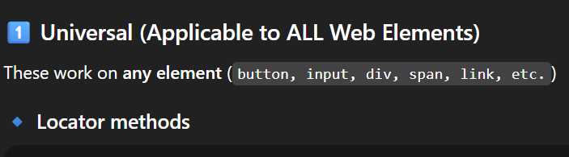

locator.click()
locator.dblclick()
locator.hover()
locator.focus()
locator.blur()
locator.scrollIntoViewIfNeeded()
locator.waitFor()
locator.boundingBox()
locator.screenshot()
locator.evaluate()
locator.evaluateAll()
locator.dispatchEvent()
locator.press('Enter')
locator.pressSequentially('abc')

State & visibility
locator.isVisible()
locator.isHidden()
locator.isEnabled()
locator.isDisabled()
locator.isEditable()
locator.isChecked()

Content
locator.textContent()
locator.innerText()
locator.innerHTML()
locator.getAttribute('class')
locator.getAttribute('id')
locator.allTextContents()
locator.allInnerTexts()

Count & traversal
locator.count()
locator.first()
locator.last()
locator.nth(index)
locator.locator('child-selector')

